Kubernetes Task-02
- Create a Simple Pod Using YAML Task: Write a YAML file to create a Pod named firstpod with an nginx container. Verify the Pod creation using kubectl get pods and check the logs of the container using kubectl logs firstpod.
- Set Environment Variables in a Pod Task: Modify the YAML file to include environment variables myname: sabair and City: Hyderabad. Deploy the Pod and use kubectl exec <pod_name> -- env to check if the environment variables are set properly.
- Deploy a Pod with Commands (Args) in YAML Task: Modify the YAML file to add args that instruct the container to sleep for 50 seconds. Deploy the Pod and use kubectl describe pod to verify the args are correctly passed to the container.
- Create a Pod with Two Containers Task: Create a YAML file to define a Pod with two nginx containers inside. Use kubectl exec to access both containers and verify that both containers can communicate through the same network (e.g., using telnet between them).
- Set Up an Init Container in a Pod Task: Modify the YAML to include an init container that sleeps for 30 seconds before the main containers start. Verify the init container's execution using kubectl describe pod and check the logs to confirm its completion.
- Run a Dry Run Command to Generate YAML Task: Use the kubectl run nginx --image=nginx --dry-run=client -o yaml command to generate a Pod YAML definition. Modify the generated YAML to suit specific requirements (e.g., labels or environment variables) and deploy it.
- Use kubectl apply vs kubectl create Task: Create a YAML file to define a Pod. First, deploy it using kubectl create -f <file_name>.yml and then modify the YAML (e.g., change the image version). Use kubectl apply to redeploy and verify the difference between both commands.
- Edit an Existing Pod Configuration Task: Use kubectl edit pod <pod_name> to modify the running Pod's environment variables or image. After making the changes, verify if they took effect by checking the container logs or environment variables using kubectl exec.
- Expose a Pod Using a Service Task: Create a YAML file to expose your firstpod using a Service (ClusterIP). Ensure that your service is exposing the Pod on port 80 and verify it using kubectl get svc.
- Pod with Resource Limits and Requests Task: Add resource requests and limits to the containers in your YAML file. Specify CPU and memory requests/limits for both containers and deploy the Pod. Use kubectl describe pod to verify if the resource configurations are correctly applied.

Task 1 — Create a Simple Pod Using YAML
Objective
Create a Pod named firstpod with an NGINX container.
Step 1: Create YAML file
Create:
vi firstpod.yaml
Add:
apiVersion: v1
kind: Pod
metadata:
name: firstpod
spec:
containers:
- name: nginx
image: nginx:latest
ports:
- containerPort: 80
Save and exit.
If using VS Code, simply create firstpod.yaml and paste the same content.

Step 2: Validate the YAML
kubectl apply --dry-run=client -f firstpod.yaml
Expected:
pod/firstpod created (dry run)
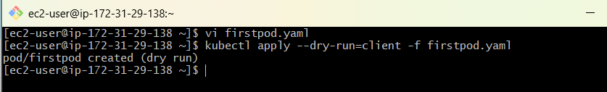

Step 3: Create the Pod
kubectl apply -f firstpod.yaml
Expected:
pod/firstpod created

Step 4: Check the Pod
kubectl get pods
Expected:
NAME READY STATUS RESTARTS AGE
firstpod 1/1 Running 0 10s

Step 5: Get detailed information
kubectl describe pod firstpod
Look for:
Name: firstpod
Container:
nginx
Image:
nginx:latest
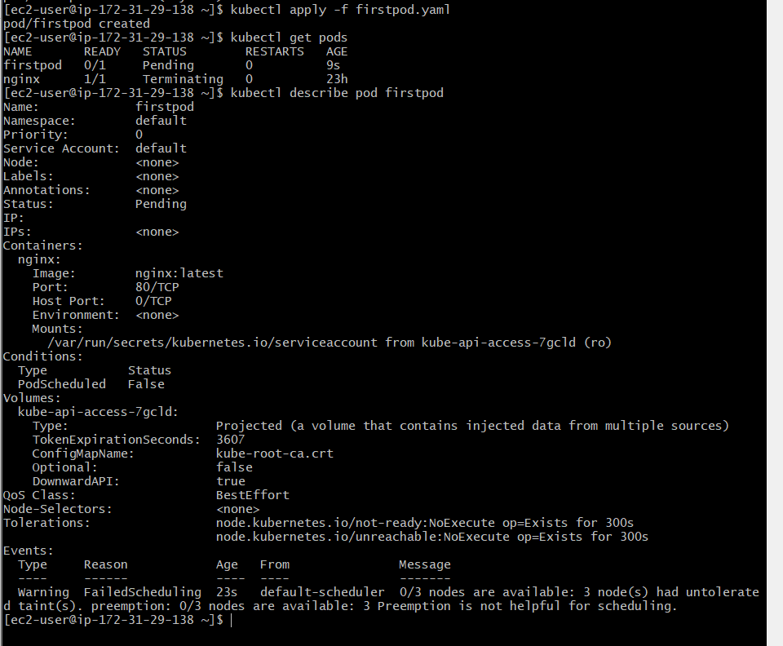

Step 6: Check logs
kubectl logs firstpod
You may see NGINX startup messages.
Step 7: Verify NGINX
kubectl exec firstpod -- nginx -v
Example:
nginx version: nginx/1.xx.x
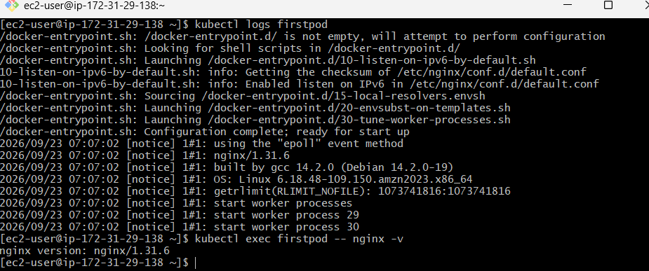

Task 2 — Set Environment Variables
Objective
Add:
myname=sabair
City=Hyderabad
to the NGINX container.

Step 1: Modify YAML
Open:
vi firstpod.yaml
Change it to:
apiVersion: v1
kind: Pod
metadata:
name: firstpod
spec:
containers:
- name: nginx
image: nginx:latest
ports:
- containerPort: 80
env:
- name: myname
value: "Venu"
- name: City
value: "Hyderabad"

Step 2: Apply
kubectl apply -f firstpod.yaml
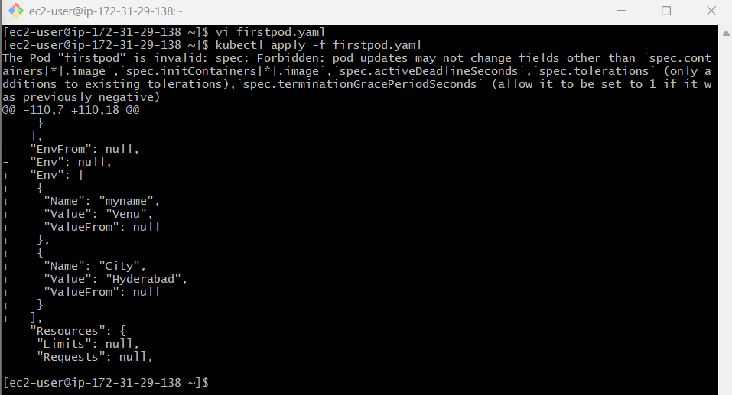

Step 3: Check environment variables
kubectl exec firstpod -- env
Search specifically:
kubectl exec firstpod -- env | grep -E 'myname|City'
Expected:
myname=Venu
City=Hyderabad
Important
env displays environment variables available inside the container.
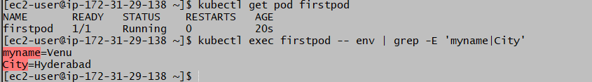

Task 3 — Deploy a Pod with Commands / Args
Objective
Make the container sleep for 50 seconds.
For this exercise, we'll use:
command:
- sleep
args:
- "50"
Important concept
Kubernetes has:
command → executable
args → arguments
So:
command:
- sleep
args:
- "50"
is equivalent to:
sleep 50

Step 1: Create YAML
Create:
vi sleep-pod.yaml
Add:
apiVersion: v1
kind: Pod
metadata:
name: sleeppod
spec:
containers:
- name: nginx
image: nginx:latest
command:
- sleep
args:
- "50"

Step 2: Deploy
kubectl apply -f sleep-pod.yaml

Step 3: Check Pod
Immediately run:
kubectl get pod sleeppod
You may see:
sleeppod 1/1 Running
After 50 seconds, it will terminate because the sleep command finishes.
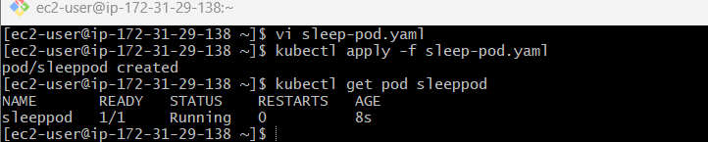

Step 4: Verify command and args
kubectl describe pod sleeppod
Look for:
Command:
sleep
Args:
50
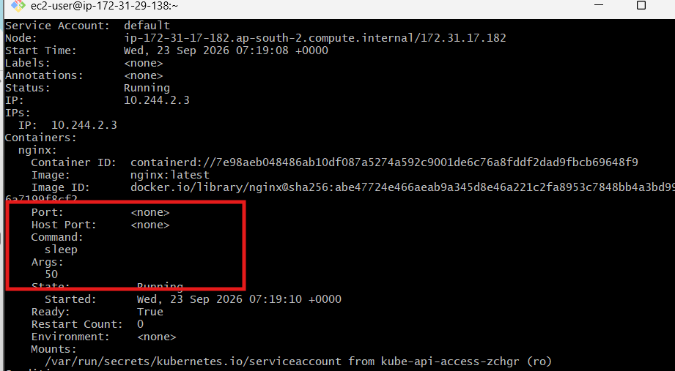

Step 5: Check logs
kubectl logs sleeppod
There may be no output because sleep doesn't generate output.
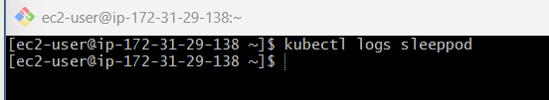

Task 4 — Create a Pod with Two Containers
Objective
Create one Pod containing two NGINX containers.
Both containers share:
- Same network namespace
- Same IP address
- Same localhost
- Same Pod

Step 1: Create YAML
vi two-container-pod.yaml
Add:
apiVersion: v1
kind: Pod
metadata:
name: twonginx
spec:
containers:
- name: nginx1
image: nginx:latest
ports:
- containerPort: 80

- name: nginx2
image: nginx:latest
command: ["/bin/sh"]
args:
- "-c"
- |
sed -i 's/listen 80;/listen 8080;/' /etc/nginx/conf.d/default.conf
sed -i 's/listen \[::\]:80;/listen [::]:8080;/' /etc/nginx/conf.d/default.conf
nginx -g 'daemon off;'
ports:
- containerPort: 8080
Step 2: Deploy
kubectl apply -f two-container-pod.yaml

Step 3: Check
kubectl get pod twonginx
Expected:
NAME READY STATUS
twonginx 2/2 Running
2/2 means both containers are running.
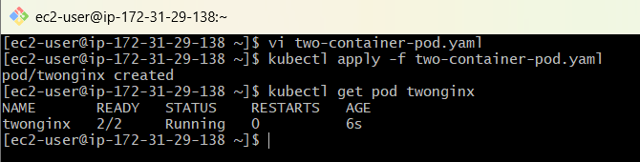

Step 4: Check both containers
kubectl exec twonginx -c nginx1 -- nginx -v
And:
kubectl exec twonginx -c nginx2 -- nginx -v
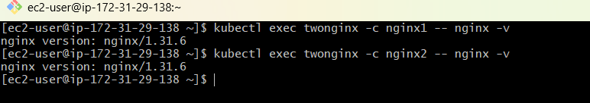

Step 5: Verify same IP
kubectl get pod twonginx -o wide
You'll see one Pod IP.
Both containers use that same Pod IP.
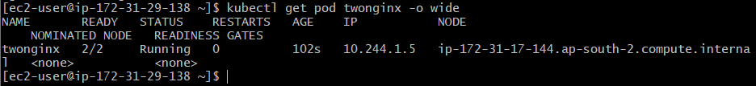

Step 6: Test communication
Because both NGINX containers listen on port 80, they cannot both bind to 0.0.0.0:80 independently within the same Pod.
Instead, you can demonstrate the shared network namespace by checking the listening port:
kubectl exec twonginx -c nginx1 -- curl localhost
If curl isn't available in the NGINX image, use:
kubectl exec twonginx -c nginx1 -- nginx -v
For a proper communication test, it's easier to use a utility container.
For example:
apiVersion: v1
kind: Pod
metadata:
name: communication-pod
spec:
containers:
- name: nginx
image: nginx:latest

- name: client
image: busybox:latest
command:
- sh
- -c
- "sleep 3600"
Deploy:
kubectl apply -f communication-pod.yaml
Then:
kubectl exec communication-pod -c sidecar -- wget -qO- http://localhost
You should receive the NGINX HTML response.
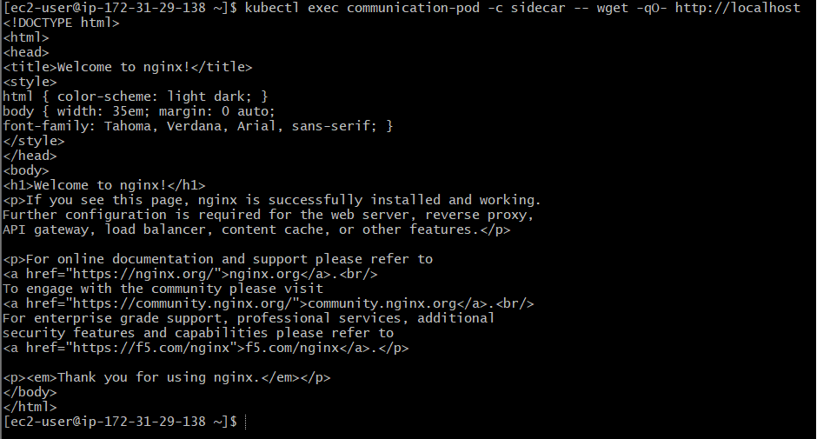
Key concept
Pod
┌─────────────────┐
│ │
│ nginx │
│ port 80 │
│ │
│ client │
│ localhost:80 ───┼──> nginx
│ │
└─────────────────┘
Containers inside the same Pod share the network namespace.

Task 5 — Init Container
Objective
Create an Init Container that sleeps for 30 seconds before the main container starts.
Important concept
Init containers run:
Init Container
↓
Completes successfully
↓
Main Container starts

Step 1: Create YAML
vi init-pod.yaml
Add:
apiVersion: v1
kind: Pod
metadata:
name: initpod
spec:
initContainers:
- name: init-container
image: busybox:latest
command:
- sh
- -c
- "echo Init container started; sleep 30; echo Init container completed"

containers:
- name: nginx
image: nginx:latest

Step 2: Deploy
kubectl apply -f init-pod.yaml

Step 3: Immediately check
kubectl get pod initpod
During the first 30 seconds you may see:
initpod 0/1 Init:0/1
This means:
Init container is running
Main container has not started yet
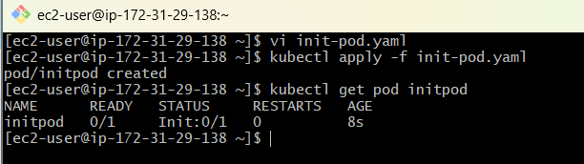

Step 4: Wait
After approximately 30 seconds:
kubectl get pod initpod
Expected:
initpod 1/1 Running

Step 5: Check Init Container logs
kubectl logs initpod -c init-container
Expected:
Init container started
Init container completed

Step 6: Describe
kubectl describe pod initpod
Look for:
Init Containers:
init-container
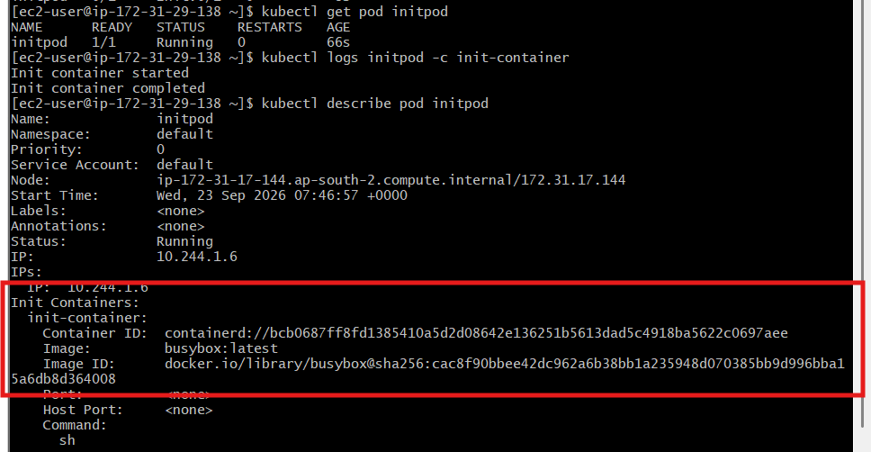

Task 6 — Dry Run to Generate YAML
Objective
Generate a Pod YAML without actually creating the Pod.

Step 1: Run
kubectl run nginx --image=nginx --dry-run=client -o yaml
This prints YAML on the screen.

Step 2: Save directly to a file
Much better:
kubectl run nginx --image=nginx --dry-run=client -o yaml > nginx.yaml
Now:
cat nginx.yaml
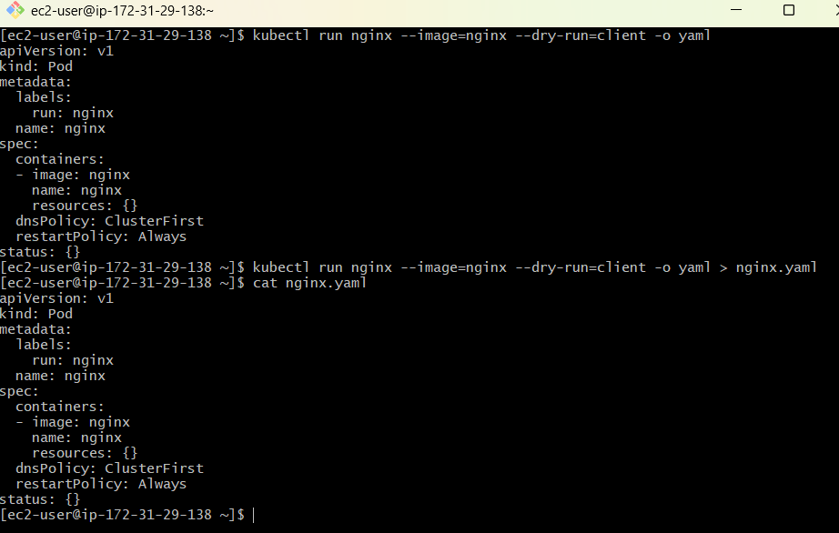

Step 3: Modify YAML
For example:
apiVersion: v1
kind: Pod
metadata:
labels:
app: nginx
environment: dev
name: nginx
spec:
containers:
- image: nginx
name: nginx
env:
- name: City
value: Hyderabad

Step 4: Deploy
kubectl apply -f nginx.yaml

Step 5: Verify
kubectl get pods --show-labels
And:
kubectl exec nginx -- env | grep City
Expected:
City=Hyderabad
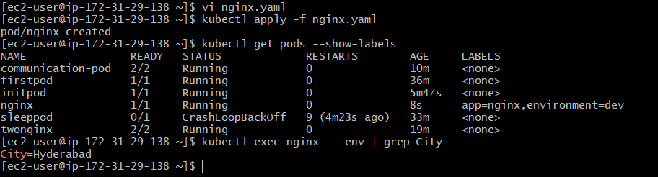

Task 7 — kubectl create vs kubectl apply
This is an important interview topic.

Part A — Using kubectl create
Create:
create-pod.yaml
apiVersion: v1
kind: Pod
metadata:
name: createpod
spec:
containers:
- name: nginx
image: nginx:1.25

Step 1: Create
kubectl create -f create-pod.yaml
Expected:
pod/createpod created

Step 2: Check
kubectl get pod createpod
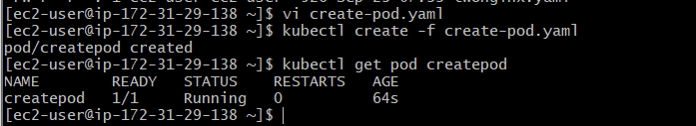

Step 3: Modify YAML
Change:
image: nginx:1.25
to:
image: nginx:1.27
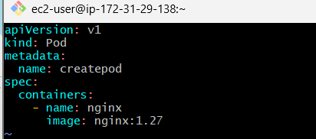

Step 4: Try create again
kubectl create -f create-pod.yaml
You'll get an error similar to:
AlreadyExists
Because the Pod already exists.
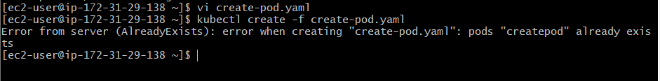

Part B — kubectl apply
Now run:
kubectl apply -f create-pod.yaml
However, Pods have limitations when changing certain fields such as the container image, so you may encounter an immutable-field error.
For a clean demonstration of apply, use a Deployment rather than a Pod:
apiVersion: apps/v1
kind: Deployment
metadata:
name: nginx-deployment
spec:
replicas: 1
selector:
matchLabels:
app: nginx
template:
metadata:
labels:
app: nginx
spec:
containers:
- name: nginx
image: nginx:1.25
Create:
kubectl apply -f deployment.yaml
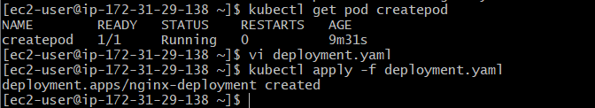
Change:
image: nginx:1.27
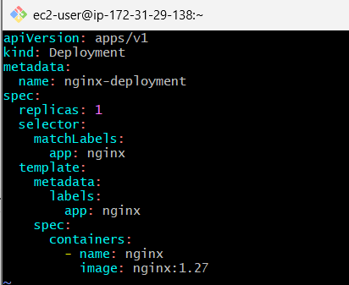
Then:
kubectl apply -f deployment.yaml
Check:
kubectl get pods
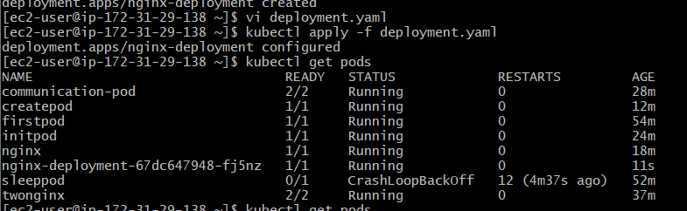
Interview point
create:
Create the resource.
If it already exists → error.
apply:
Create or update the resource according to the YAML configuration.
For production Kubernetes workloads, Deployments are generally preferred over managing individual Pods directly.

Task 8 — Edit an Existing Pod
Objective
Use:
kubectl edit pod
to modify an existing Pod.

Step 1: Create a Pod
apiVersion: v1
kind: Pod
metadata:
name: editpod
spec:
containers:
- name: nginx
image: nginx:latest
env:
- name: City
value: Hyderabad
Apply:
kubectl apply -f editpod.yaml

Step 2: Verify
kubectl exec editpod -- env | grep City
Expected:
City=Hyderabad
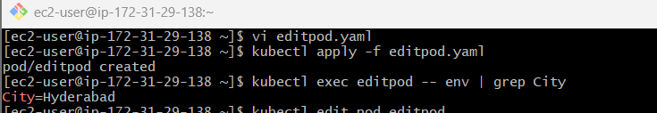

Step 3: Edit
Run:
kubectl edit pod editpod
Find:
value: Hyderabad
Change to:
value: Guntur
Save and exit.
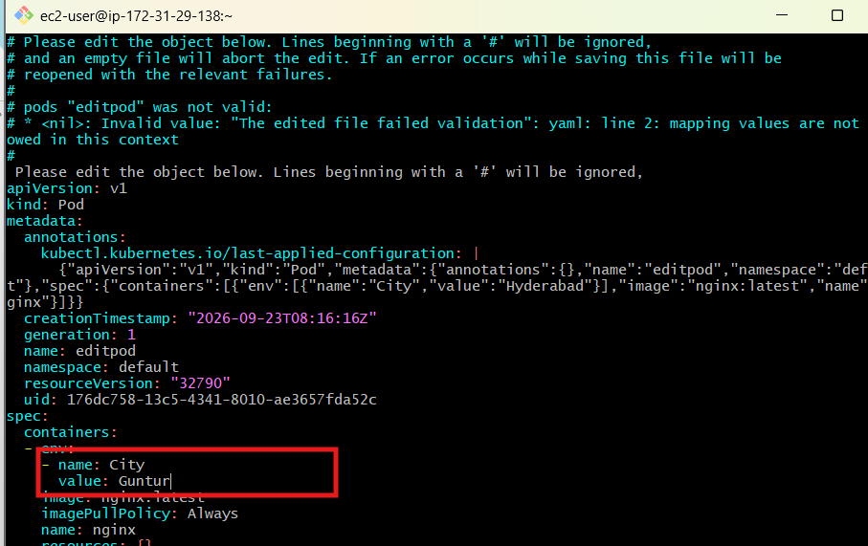
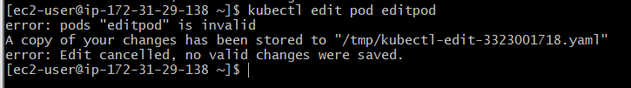

Important
A running Pod is not freely editable. Many Pod fields are immutable.
If Kubernetes rejects the change, that's expected.
For real-world workloads, use a Deployment and change the Deployment YAML instead of manually editing Pods.
For environment variables, the safer production approach is:
Deployment
↓
ConfigMap / Secret
↓
Pod

Task 9 — Expose Pod Using Service
Objective
Create a ClusterIP Service for firstpod.

Step 1: Check Pod label
Our original Pod needs a label.
Update:
apiVersion: v1
kind: Pod
metadata:
name: firstpod
labels:
app: firstpod
spec:
containers:
- name: nginx
image: nginx:latest
ports:
- containerPort: 80
Apply:
kubectl apply -f firstpod.yaml
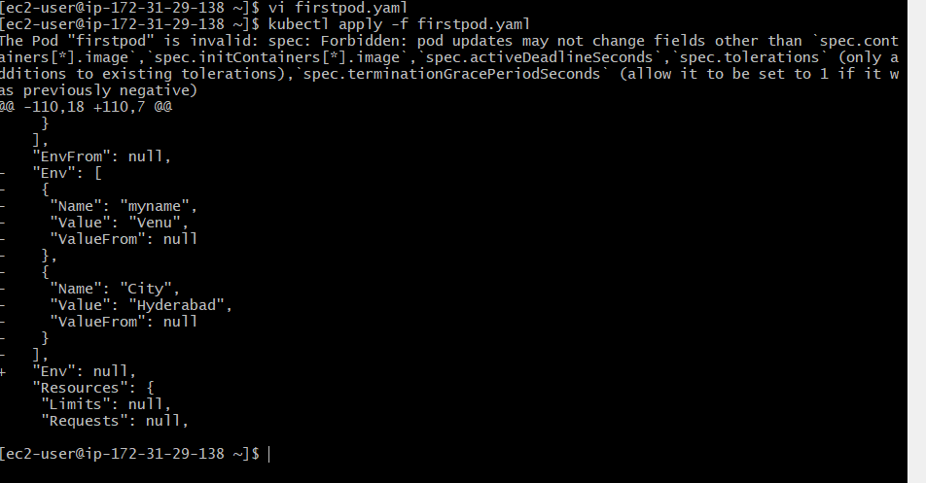

Step 2: Create Service YAML
Create:
vi firstpod-service.yaml
Add:
apiVersion: v1
kind: Service
metadata:
name: firstpod-service
spec:
type: ClusterIP
selector:
app: firstpod
ports:
- port: 80
targetPort: 80

Step 3: Deploy Service
kubectl apply -f firstpod-service.yaml

Step 4: Check Service
kubectl get svc
Expected:
NAME TYPE CLUSTER-IP PORT(S)
firstpod-service ClusterIP 10.xxx.xxx.xxx 80/TCP
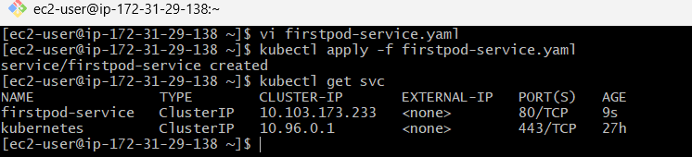

Step 5: Check endpoints
This is important:
kubectl get endpoints firstpod-service
You should see the Pod IP and port:
10.x.x.x:80
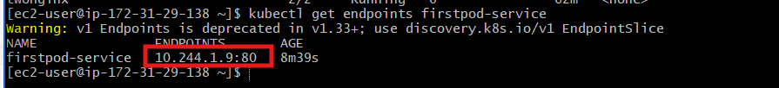
This confirms:
Service
↓
Selector
↓
Pod
↓
NGINX :80

Task 10 — Resource Requests and Limits
Objective
Set:
- CPU request
- Memory request
- CPU limit
- Memory limit

Step 1: Create YAML
vi resources-pod.yaml
Add:
apiVersion: v1
kind: Pod
metadata:
name: resourcepod
spec:
containers:
- name: nginx1
image: nginx:latest
resources:
requests:
cpu: "100m"
memory: "128Mi"
limits:
cpu: "500m"
memory: "256Mi"

- name: nginx2
image: nginx:latest
resources:
requests:
cpu: "100m"
memory: "128Mi"
limits:
cpu: "500m"
memory: "256Mi"

Step 2: Understand the values
CPU
100m = 0.1 CPU
500m = 0.5 CPU
m means millicpu.
Memory
128Mi
256Mi
means:
128 MiB
256 MiB

Step 3: Deploy
kubectl apply -f resources-pod.yaml

Step 4: Check
kubectl get pod resourcepod
Expected:
resourcepod 2/2 Running
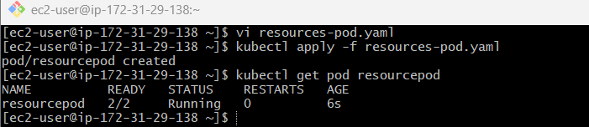

Step 5: Describe
kubectl describe pod resourcepod
Look under:
Containers:
nginx1:
Limits:
cpu: 500m
memory: 256Mi
Requests:
cpu: 100m
memory: 128Mi

nginx2:
Limits:
cpu: 500m
memory: 256Mi
Requests:
cpu: 100m
memory: 128Mi
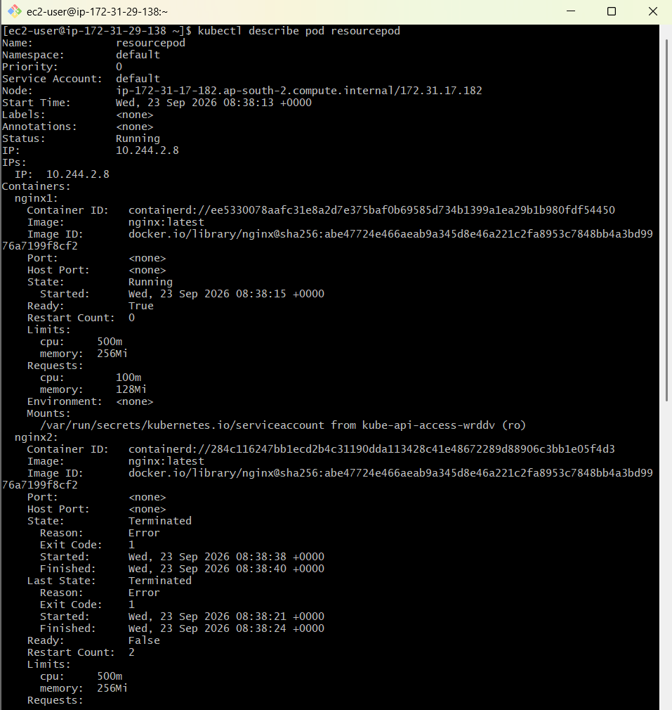

Complete Lab Flow
You can remember the 10 tasks like this:
KUBERNETES POD LAB
│
┌──────────────────┴──────────────────┐
│ │
BASIC POD POD FEATURES
│ │
1. Simple Pod 2. Environment
3. Commands/Args
4. Two Containers
5. Init Container
6. Dry Run YAML
7. Create vs Apply
8. Edit Pod
9. Service
10. Resources

